Dear Parents,

Accessing Glow and Education City

Instructions for accessing Glow and Microsoft Teams Classroom:

- Type into your search bar:
Glow Login or https://glow.rmunify.com . This login screen will appear.
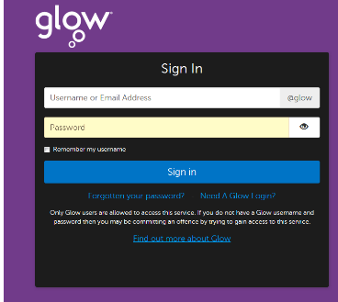

- Enter your login details:
Username:
Password:

- Your Launch Pad will open
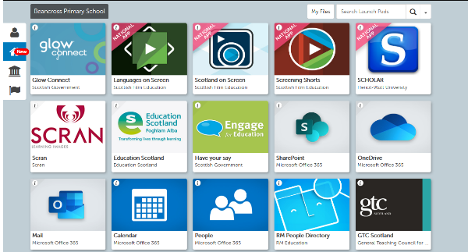

Instructions for accessing Microsoft Teams Classroom
- In the Glow Launch Pad click on the Microsoft Teams App
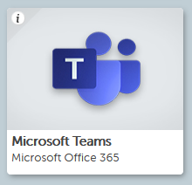

Instructions for accessing Education Scotland
- Type into your search bar:
Education Scotland or https://www.educationcity.com/
The login screen will appear.
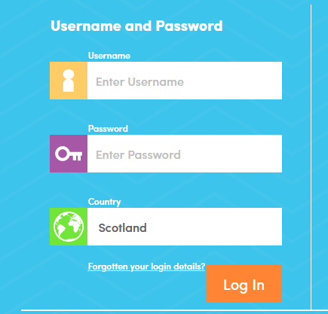

- Enter your login details:
Username:
Password:

- The child’s home screen will then appear.
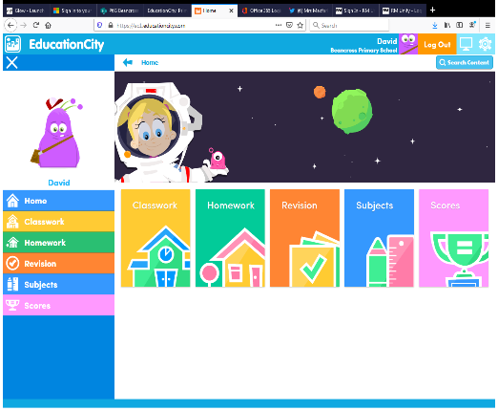

Children can access set classwork and homework tasks. Children can also search using the ‘search content’ bar for other ‘activities’ and ‘Play Live’ games.

If you child does not have access to internet from home please contact your child’s class teacher and they can set additional homework tasks.

Thank you for your support,

Yours Sincerely,


Stephanie Macfarlane
Acting Depute Headteacher

