Accessing Borrow Box on Glow

Borrow Box is an eBooks and audiobooks library. Children can access the app for free from their Glow Launch pad.
Instructions for borrowing a text from Borrow Box:
1. Click on the Borrow Box App.
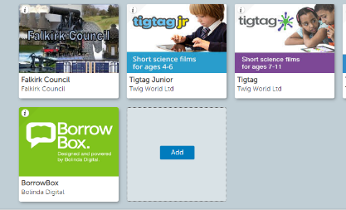
2. Select either Audiobooks or eBooks.
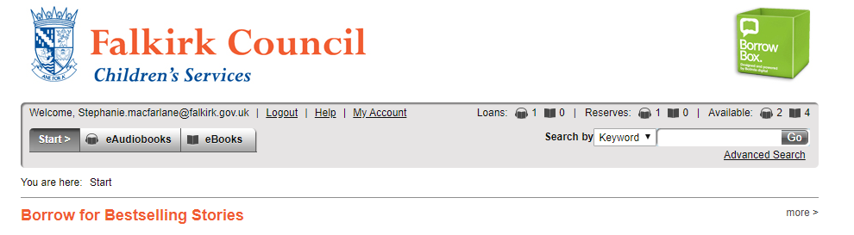
3. Search for a specific Audiobook or eBook or alternatively browse through the catalogue.
4. When you find the text you want click on it. If the text is available you can click ‘borrow’ to confirm your loan and download the text. If the text is ‘on loan’ you can reserve the text for when it becomes available. You will receive an email to your glow email account reminding you when it becomes available or you can make a note of the date displayed.
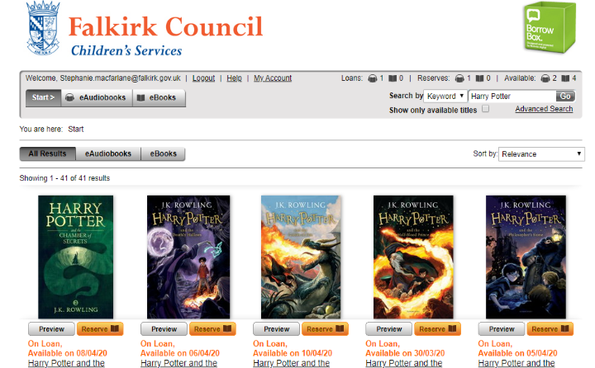

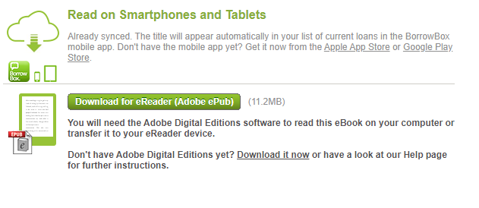
5. Enjoy your audiobook and eBooks.

